

**WELCOME TO GOOD SHEPHERD EVANGELICAL LUTHERAN CHURCH**

 We have gathered to meditate at Vespers. Vespers is an evening service, coming from one of the daily offices at which the Church meets to meditate upon God’s Word. Our particular order is called Evening Prayer. In this service, our Triune God is pleased to serve us with his promises and mercy. Lenten Vespers focus on the coming of the Messiah to forgive sins and to bring us into his eternal kingdom.

If you are visiting with us this evening, we ask you to sign our guest book by the church entrance. If you would like to learn more about the Evangelical Lutheran Church – its confession or its practice, please speak to the pastor. We hope you will join us again soon.



**Lenten Vespers**

      

**AD 2021, March 17**

**EVENING PRAYER**

**VESPERS**

**Opening Hymn --** **99 Oh, Come, My Soul**

<https://hymnary.org/hymn/CWLH1993/99>

**M:** O Lord, open my lips.

**C: And my mouth shall declare your praise.**

**M:** Hasten to save me, O God.

**C: O Lord, come quickly to help me.**

**M:** The Lord be with you.

**C: And also with you.**

**M:** Lord God, you have brought us safely to this hour of evening prayer. We thank you for providing all that we need for body and life. Bless us who have gathered in your name. Forgive our sins. Speak to our hearts. Dispel our sorrows with the comfort of your Word, and receive our hymns of thanks and praise, through Jesus Christ, our living Savior, who reigns with you and the Holy Spirit, one God, now and forever.

**C: Amen.**

## LET MY PRAYER RISE BEFORE YOU

#### Psalm 141

**C: Let my prayer rise before you as incense, the lifting up of my hands as the evening sacrifice.**

**O Lord, I call to you; come to me quickly; hear my voice when I cry to you.**

**Let my prayer rise before you as incense, the lifting up of my hands as the evening sacrifice.**

**M:** Let our prayers be acceptable in your sight. Come and help us in time of need that we may sing your praise in holy joy now and forever, through Jesus Christ, our Lord.

**C: Amen.**

**Psalm of the Day -- Psalm 2** *Sung In Unison*



***Refrain***

Great are the works of the Lord. Alleluia! Alleluia!

Great are the works of the Lord.

Why do the nations conspire*

and the peoples plot in vain?

The kings of the earth take their stand and the rulers

gather together against the LORD*

and against his Anointed One.

***Refrain***

The One enthroned in heaven laughs;*

the Lord scoffs at them.

Then he rebukes them in his anger

and terrifies them in his wrath, saying,*

“I have installed my King on Zion, my holy hill.”

I will proclaim the decree of the LORD:*

He said to me, “You are my Son;

today I have become your Father.”

**Glory be to the Father and to the Son\***

**and to the Holy Spirit,**

**as it was in the beginning,\***

**is now, and will be forever. Amen.**

***Refrain***

Refrain Tune: Kermit G. Moldenhauer. © 1993 Kermit G. Moldenhauer (admin. Northwestern Publishing House). All rights reserved. Used by permission.

**Psalm Prayer** Lord God, you anointed your Son to be king for the sake of your Church. Help us, as members of his kingdom, to serve him faithfully and to come to the full knowledge of his grace and glory, who lives and reigns with you and the Holy Spirit, one God, now and forever.

**C: Amen.**

**THE PASSION OF OUR LORD Mark 14:66-15:15**

And as Peter was below in the courtyard, one of the servant girls of the high priest came, and seeing Peter warming himself, she looked at him and said, “You also were with the Nazarene, Jesus.” But he denied it, saying, “I neither know nor understand what you mean.” And he went out into the gateway and the rooster crowed. And the servant girl saw him and began again to say to the bystanders, “This man is one of them.” But again he denied it. And after a little while the bystanders again said to Peter, “Certainly you are one of them, for you are a Galilean.” But he began to invoke a curse on himself and to swear, “I do not know this man of whom you speak.” And immediately the rooster crowed a second time. And Peter remembered how Jesus had said to him, “Before the rooster crows twice, you will deny me three times.” And he broke down and wept.

And as soon as it was morning, the chief priests held a consultation with the elders and scribes and the whole council. And they bound Jesus and led him away and delivered him over to Pilate. And Pilate asked him, “Are you the King of the Jews?” And he answered him, “You have said so.” And the chief priests accused him of many things. And Pilate again asked him, “Have you no answer to make? See how many charges they bring against you.” But Jesus made no further answer, so that Pilate was amazed.

Now at the feast he used to release for them one prisoner for whom they asked. And among the rebels in prison, who had committed murder in the insurrection, there was a man called Barabbas. And the crowd came up and began to ask Pilate to do as he usually did for them. And he answered them, saying, “Do you want me to release for you the King of the Jews?” For he perceived that it was out of envy that the chief priests had delivered him up. But the chief priests stirred up the crowd to have him release for them Barabbas instead. And Pilate again said to them, “Then what shall I do with the man you call the King of the Jews?” And they cried out again, “Crucify him.” And Pilate said to them, “Why? What evil has he done?” But they shouted all the more, “Crucify him.” So Pilate, wishing to satisfy the crowd, released for them Barabbas, and having scourged Jesus, he delivered him to be crucified.

**Seasonal Response**

**All: All we, like sheep, have gone astray, and the Lord has laid on him the iniquity of us all.**

**By his wounds we are healed.**

**Chief Hymn -- 115** **He Stood before the Court**

<https://hymnary.org/hymn/CWLH1993/115>

**The Sermon** **Mark 14:55-65**

THE HANDS OF THE PASSION

Hands of Hypocrisy (Caiaphas)

**Hymn 268 Lamb of God, Pure and Holy** *(replacing Song of Mary)*

<https://hymnary.org/hymn/CWLH1993/268>

***The following prayer or other prayers may be used concluding with the LORD’S PRAYER and the PRAYER FOR PEACE.***

**LORD, HAVE MERCY**

#### Kyrie

**M:** In the closing hours of this day, hear us as we pray, O Lord:

**C: Lord, have mercy.**

**M:** For the well-being of people everywhere, for the growth of your church in all the world, and for the strengthening of all who serve and worship here, we pray, O Lord:

**C: Christ, have mercy.**

**M:** For one another, young and old, for your blessings that come with every stage of life, and for joy in doing your will, we pray, O Lord:

**C: Lord, have mercy.**

**M:** For our public servants who work day and night to bring protection, justice, learning, and health to this and every place, we pray to you, O Lord:

**C: Lord, hear our prayer.**

**M:** For favorable weather and bountiful harvests, for clothing and food, for health of body, mind, and spirit, and for deliverance from all sin and every form of evil, we pray to you, O Lord:

**C: Lord, hear our prayer.**

**M:** For the faithful who have gone before us, who have shared with us your good news, whose souls are now at rest in your heavenly kingdom, we give you thanks, O Lord:

**M: Thanks be to God.**

**C:** In thanksgiving for your many and varied gifts to us, we now commend ourselves to your care. Be our shield and strength, O Lord.

**C: Amen.**

**LORD’S PRAYER**

**C: Our Father, who art in heaven, hallowed be thy name, thy kingdom come, thy will be done on earth as it is in heaven. Give us this day our daily bread; and forgive us our trespasses, as we forgive those who trespass against us; and lead us not into temptation, but deliver us from evil. For thine is the kingdom and the power and the glory forever and ever. Amen.**

**PRAYER FOR PEACE**

**M:** Lord God, all holy desires, all good counsels, and all just works come from you. Give to us, your servants, that peace which the world cannot give, that our hearts may be set to obey your commandments. Defend us also from the fear of our enemies that we may live in peace and quietness, through the merits of Jesus Christ our Savior, who lives and reigns with you and the Holy Spirit, one God, now and forever.

**C: Amen.**

### SONG OF SIMEON

#### Nunc Dimittis

**C: In peace, Lord, you let your servant now depart according to your word. For my eyes have seen your salvation, which you have prepared for ev’ry people, a light to lighten the Gentiles and the glory of your people Israel.**

**BLESSING**

**M:** The grace of our Lord (+) Jesus Christ and the love of God and the fellowship of the Holy Spirit be with you all.

**C: Amen.**

**Closing Hymn -- 118 O Dearest Lord, Thy Sacred Head**

<https://hymnary.org/hymn/CWLH1993/>118

Evening Prayer © 1993 Northwestern Publishing House. All rights reserved.

“Service of Light” Text, Music: © 1978 *Lutheran Book of Worship*. All rights reserved. Used by

permission of Augsburg Fortress.

“Let My Prayer Rise Before You” © 1978 *Lutheran Book of Worship*. All rights reserved. Used

by permission of Augsburg Fortress.

**Intercessions**

*Intercessions that are requested prior to the bulletin’s printing will be included in the bulletin. Requests may be made prior to the service as well.*

Preacher– Rev. Paul Schaefer, St. Peters, Plymouth

Organist Jeanette Schneider

**REGULAR SCHEDULE**

Divine Service is Sundays at 10:00 AM, in person and on Facebook Live.

Sunday School & Adult Bible Class is on Sunday at 8:45 AM.

Lenten Vespers will be on Wednesdays at 7:00 PM through March 24.

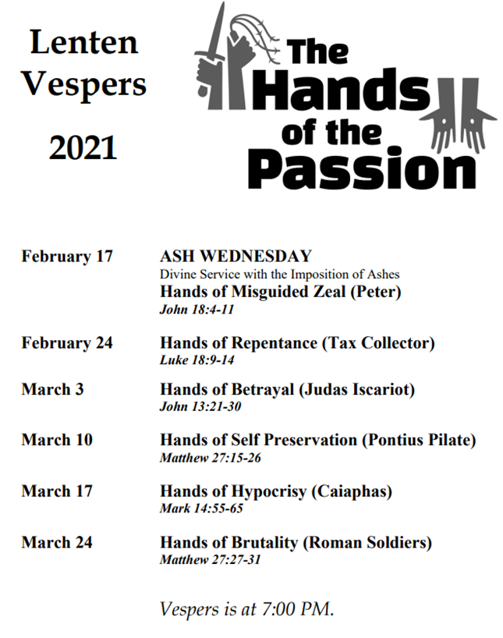



**Good Shepherd Evangelical Lutheran Church (WELS)**

**41415 W. 9 Mile Road Novi, Michigan 48375-4306**

Office Phone Web Site Church E-Mail

(248) 349-0565 [**www.GoodShepherdNovi.org**](http://www.welsnovi.org/)  [welsnovi@aol.com](mailto:%20%20%20welsnovi@aol.com)

**Pastor Thomas E. Schroeder**

Pastor’s Cell Phone (248) 719-5218

Pastor's Blog – [www.LutheranSubject.blogspot.com](http://www.LutheranSubject.blogspot.com/)

We encourage our members to utilize opportunities for Christian education, grounded in the Evangelical-Lutheran faith. While we do not own and operate a school on our property, we are able to enroll our children at the following schools.

**St. Peter Lutheran School St. Paul Lutheran School Huron Valley Lutheran High School**

(Pre-K only) (Pre-K through 8th grade) (9th grade thru 12th grade)

1343 Penniman Avenue 17810 Farmington Road 33740 Cowan Road

Plymouth, MI 48170 Livonia, MI 48152 Westland, MI 48185

(734) 421-9022 (734) 453-0460 (734) 525-0160

[**www.splp.org**](http://www.splp.org)[**www.stpaulslivonia.org**](http://www.stpaulslivonia.org)[**www.hvlhs.org**](http://www.hvlhs.org)

Becky Lohrmann, teacher Mr. Paul Leifer, principal Mr. Matt Foley, principal